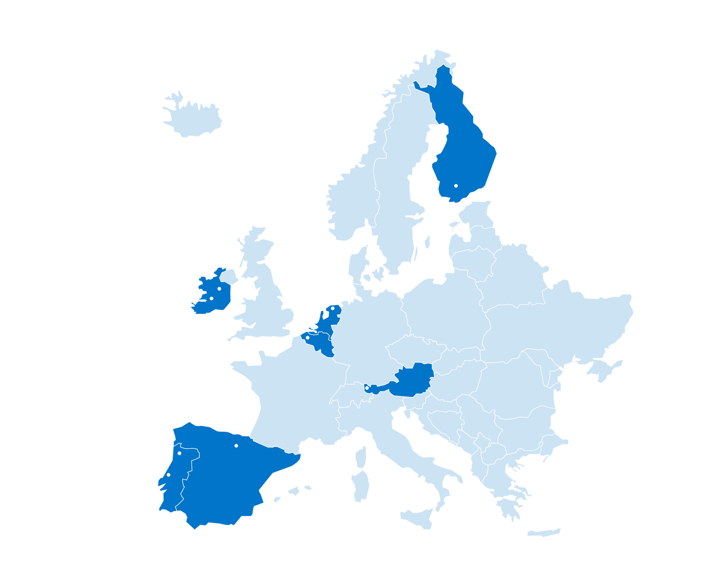

RUN-EU Impact Showcase Challenge Template

Academic Year 2025-2026

RUN-EU Impact Observatory

|  |
| --- |
| **Template guidance note**   * Before filling in this template please carefully familiarize yourself with the different sections and instructions provided. * All sections of the template should be completed. * Maximum word count should be respected. * We request that a lead contact person from a RUN-EU HEI is identified for this case study who can provide further information on this case study if required by us. The lead contact is the person with a chance to win the award. * This form provides the template to report on impact case studies of your RUN-EU activity and should be submitted by e-mail in pdf- and word-format to [run-eu@howest.be](mailto:run-eu@howest.be) by **23:59 CET on the 25th of May.** * The RUN-EU Impact Showcase Challenge is open to all staff of RUN-EU, regardless of their discipline or function within their institution or the type of RUN-EU activity. * Only RUN-EU activities that took place from September 2024 onward are eligible for submission. * There is no limit on the amount of case studies that can be submitted by each institution. To be eligible for the competition, the official template provided by RUN-EU should be used and all applicable sections should be completed. * There is no limitation in the amount of persons that are involved in creating the submission for the challenge, however, one person should be designated as the lead contact for the case study. * The RUN-EU activity that is the subject of the case study should take place at the institution of the lead contact person of the Impact Showcase Challenge submission. * For questions on this form contact [run-eu@howest.be](mailto:run-eu@howest.be).   **Data protection**  Data received via this form can be used for internal evaluation of our activities, can be published on the RUN-EU website and social networks, and can be used for reports and events on the impact of RUN-EU. Your personal data will be handled in line with GDPR regulations. You have the right to access, rectify, and delete your data or withdraw your consent at any time by contacting the organisers of the Impact Showcase Challenge. If personal data that may allow people to be identified is employed in this case study you should explicitly get their permission to use their information for this impact showcase that may be shared internally and externally (see informed consent form in the appendix). By submitting this case study, you agree with these terms. |

Table of Contents:

1. Contact details 4

2. Overview of the RUN-EU activity 4

3. Impact assessment case study 5

# Contact details

|  |  |
| --- | --- |
| Name of institution |  |
| Name of lead contact |  |
| Role of lead contact in institution |  |
| Institutional e-mail of lead contact |  |

We request that one contact person is identified for this case study who can provide further information on this case study if required.

# Overview of the RUN-EU activity

|  |
| --- |
| Name of the RUN-EU activity **[word limit: 60]** |
| [Word count: ] |

|  |
| --- |
| Start and end date of the activity **[word limit: 30]** |
| [Word count: ] |

|  |
| --- |
| What were the most important things on the programme of the activity? **[word limit: 250]** |
| [Word count: ] |

|  |
| --- |
| In the tasks of which RUN-EU work package(s) did the activity fit? **[word limit: 30]** |
| [Word count: ] |

|  |
| --- |
| Which Higher Education Institution(s) was(were) involved in the preparation of the activity? **[word limit: 30]** |
| [Word count: ] |

|  |
| --- |
| Were there any external stakeholders involved in the event? If so, who were these external stakeholders? **[word limit: 200]** |
| [Word count: ] |

|  |
| --- |
| Who was the activity aimed for? **[Word limit: 250]** |
| [Word count: ] |

|  |
| --- |
| What were the objectives and desired outcomes of the activity? **[Word limit: 300]** |
|  |

# Impact assessment case study

|  |
| --- |
| Provide a narrative, with supporting evidence, to explain the nature and extent of the impact of this activity. Clearly specify, **who or what**was impacted by the activity (beneficiaries) and **how.**Add **precise evidence** for this wherever possible (quantitative and/or qualitative data for instance by conducting interviews, testimonials and administering surveys).  Note that impact refers to change, thus the description of your impact should specify what change your activity had for its beneficiaries. **[Word limit: 1000, excluding tables and figures]** |
| [Word count: ] |

|  |
| --- |
| How did you go about obtaining the information on which your impact statement in the previous question is based? Describe your strategy here. **[Word limit: 200]** |
| [Word count: ] |

|  |
| --- |
| What factors do you believe have contributed to the successful impact of the event/activity? **[Word limit: 200]** |
| [Word count: ] |
| What factors do you believe could have helped to make more positive impact? **[Word limit: 200]** |
| [Word count: ] |

|  |
| --- |
| By submitting and signing this form, I declare that:   1. The information provided in this case study submission is true and accurate.      1. I consent to the use of the data received through this form for the internal evaluation of our activities, publication on RUN-EU website and social media, and use in reports and events related to RUN-EU's impact.      1. I confirm that the informed consent of all participants for the use of their personal data (when applicable) has been obtained through the RUN-EU signed informed consent forms.      1. I consent to my data being processed in accordance with the privacy policies of Howest. Accessible at <https://www.howest.be/en/privacy-and-copyrights>. 2. I guarantee that all personal data will be processed in accordance with the applicable data protection regulations, maintaining its confidentiality and security. 3. It is hereby reaffirmed that participation in the study was voluntary, and that participants were informed of their right to withdraw consent at any time without penalty. 4. IF APPLICABLE: It is hereby declared that the study was conducted in accordance with the applicable ethical guidelines and, if necessary, approved by an ethics committee. |
| Date and autograph of lead contact person: |

|  |
| --- |
| On behalf of **[insert HEI]** I declare that the information supplied in this case study submission is true and correct. |
| Date and autograph of the head of the institution: |

Appendix

The following Informed Consent Form should be employed by the organisers of the case study when collecting personal data.

RUN-EU Consent Form

|  |  |
| --- | --- |
| **Title**  (Mrs., Ms., Mr., Mx., Prof., Dr., or other) |  |
| **First Name** |  |
| **Surname** |  |
| **Email** |  |
| **Organisation (if applicable)** |  |
| **Job title (if applicable)** |  |
| **Associated work package (if applicable)** |  |

By signing below, I hereby declare that all information provided, as well as the photographs, that may be sent as an attachment, can be published on the RUN-EU website and social networks and can be used for reporting on the impact of RUN-EU.

I also acknowledge that the writing style may be adapted to ensure it is consistent with the RUN-EU Style Guide (available online and upon request).

I am informed that participation in the study is voluntary, and that I have the right to withdraw consent at any time without penalty.

Date:

Place:

Name:

Signature:

